**PERANCANGAN DATABASE**

1. **CDM (*Conceptual Data Model*)**

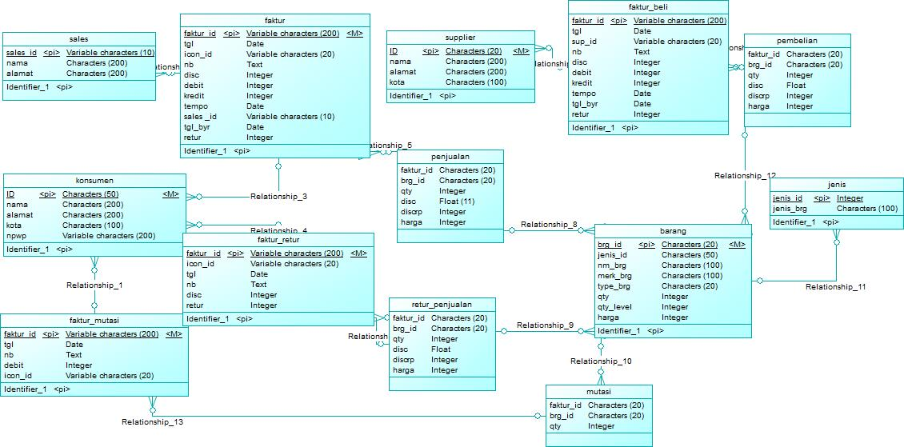

1. **PDM (*Physical Data Model)***

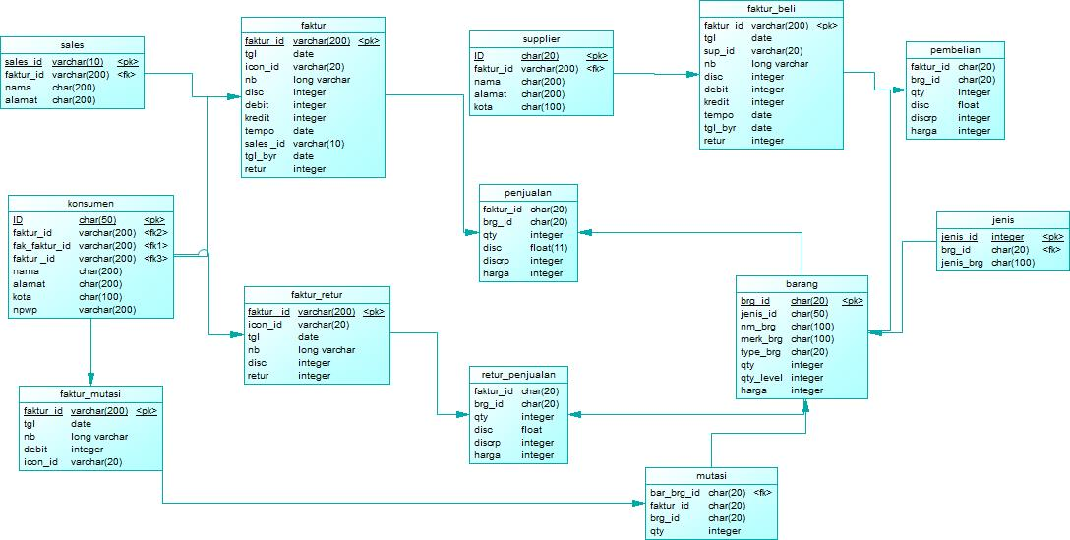

1. **ERD (*Entity Relationship Diagram*)**

